Stage 3 Physics STAWA Set 11: Photons

1 E = 2.0x10-24J
c = 3.0x108ms-1
h = 6.63x10-34Js

a E = h.f
f = 
= 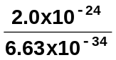
f = 3.0x109Hz

b c =
= 
= 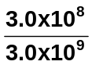
= 1.0x10-1m (=10cm)

c Compared with visible light, microwaves have lower energies, lower frequencies and longer (greater) wavelengths.

2 c = 3.0x108ms-1
h = 6.63x10-34Js
red = 680nm = 680x10-9m
orange (amber) = 580nm = 580x10-9m
green = 500nm = 500x10-9m

c = 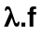
f =
red f = 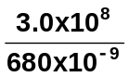
= 4.4x1014Hz
orange f = 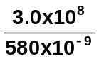
= 5.2x1014Hz
green f = 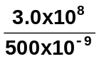
= 6.0x1014Hz

E = h.f
red E = 6.63x10-34 x 4.4x1014
= 2.9x10-19J
orange E = 6.63x10-34 x 5.2x1014
= 3.4x10-19J
green E = 6.63x10-34 x 6.0x1014
= 4.0x10-19J
3 Eav(X-rays) = 1x104eV
Eav(-rays) = 1x107eV

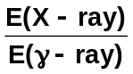 = 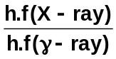
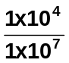 = 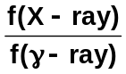
ratio of frequencies = 1x10-3:1

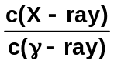 = 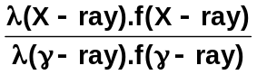
1 = 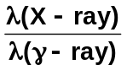 x 1x10-3
= 1x103
ratio of wavelengths = 1x103:1

4 P = 1.0W
c = 3.0x108ms-1
h = 6.63x10-34Js
= 694nm = 694x10-9m

a 694nm is a 'red' wavelength

b E = h.f
and c = .f
E = 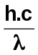
= 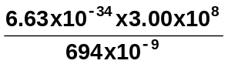
E = 2.87x10-19J / photon

c A = 10mm2 = 10x10-6m2

I = 
= 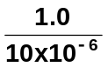
I = 1x105Wm-2.

d I (sunlight) = 1000Wm-2
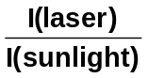 = 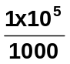
= 100
The laser beam is 100 times more intense than sunlight.

5 P = 750W (output power)
= 750Js-1
E (photon) = 1.0x10-23J
t = 1.0s

P =
E = P.t
= 750 x 1
= 750J
Number of photons = 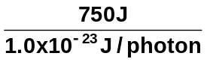
= 7.5x1025 photons

6 = 6.0x10-7m
P = 1.7x10-8W = 1.7x10-8Js-1.
c = 3.0x108ms-1

P =
E = P.t
= 1.7x10-8 x 1
= 1.7x10-8J (per second)

E = h.f
and c = .f
E =
= 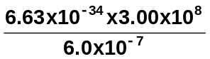
photon energy = 3.3x10-19J

photons / second = 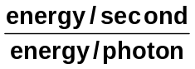
= 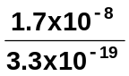
photons / second = 5.1x1010

7 P = 50kW = 50x103W
f = 720kHz = 720x103Hz
c = 3.0x108ms-1

a c =
=
= 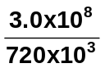
= 4.2x102m

b t = 1 day
= 8.64x104s

P =
E = P.t
= 50x103 x 8.64x104
E = 4.3x109J

8 Graph (a) - shows absorption of the short wavelengths, blue and violet, but transmission of the long wavelengths, i.e. red. Therefore, this is red filter.
Graph (b) - shows transmission of both blue and red, but absorption of the middle frequencies. This is a purple filter.
Graph (c) - shows maximum transmission at 500nm, and as this is the frequency of green light, this is the green filter.

9. Some of the following is from http://en.wikipedia.org/wiki/Blue_shift
Blue shift is the shortening of a transmitted signal's wavelength, and/or an increase in its frequency, due to the Doppler Effect, which indicates that the object is moving toward the observer. The name comes from the fact that the shorter-wavelength end of the optical spectrum is the blue (or violet) end, hence, when visible light is compacted in wavelength, it is shifted towards the "blue" end of the spectrum. Since the longer-wavelength end of the visible electromagnetic spectrum is red, the opposite effect, of a lengthening of a signal's wavelength, is referred to as redshifting.
While the terms "redshifting" and "blueshifting" imply significantly redder or bluer light, only the most distant galaxies and those moving at speeds far above average emit light that arrives with perceptible red or blue tinges. For the most part, shifting is not a visible phenomenon.
These terms and conventions ("blue" = compaction, "red"= diffusing) are used even when referring to signals outside the optical range (for instance, radio waves, x-rays and gamma rays).
If the universe is expanding then the stars, etc are moving further away so they would have longer wavelengths and have a red shift. As this is the case with most of the celestial objects we look at, it is suggested that our universe is expanding so blue shift will not occur in an expanding universe.
- While not in the course, Hubble’s constant is v = H₀D or H₀ =  where v = is the velocity of the celestial object and D is the distance to the celestial object. The most recent value is suggested to be H₀ = 70.6 ± 3.1 (km/sec)/Mpc although it has been as high as 500 km s⁻¹ Mpc⁻¹.

Now to the question.
From the line of best fit on the graph (very rough) for v = 10 000 km s⁻¹, D = about 17 Mpc

H₀ = 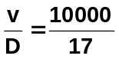= 588 km s⁻¹ Mpc⁻¹.

No answer is given in Exploring Physics at the moment so I don’t know if this is what they are looking for but the value seems to be too high.

